

http://clearairtools.com/

A builder finished his left wing and began on the right wing. He used the same techniques on the right wing that he used on the left wing. The dimple dies were the same, the drill bits were of the same size and manufacturer, and the rivet types and sizes were the same. However, the finished rivets on the right wing had a distinctly different appearance to his discriminating eye (☺) than the rivets on the left wing. After all of his painstaking attention to detail, that’s enough to cause this builder more than a little turmoil.

What has this builder done wrong? Probably nothing at all.

Welcome to the World of Tolerances.

Let’s take a look, step by step, at the building process and closely examine some of the details.

- Van’s prepunches the kits to fractional sizes. Therefore, the hole for a 3/32 rivet is prepunched to 3/32 fractional (.0938) and the hole for a 1/8” rivet is prepunched to 1/8” fractional (.1250). A #40 drill bit is sized to .0980 and a #30 drill bit is sized to .1285. Assuming that the CNC punch is new and sharp, the 3/32 hole is .0042 undersized and the 1/8” hole is .0035 undersized when compared to ideal finished dimensions, i.e., #40 and #30.

- DRILL BITS: True American Manufactured NAS 907-J Cobalt Drill Bits are heavy duty, 135 Degree Split Point, M-42 Cobalt Jobbers Length Drill bits manufactured to a Rockwell C of 66-67.5 and held to a diameter tolerance of +/- .003. Other drill bits are manufactured to different tolerances.

- REAMERS: Aerospace quality reamers are typically held to tolerances of + .0002/-0.

- RIVETS: Below is a MilSpec label off of a package of MS20426 B 5-7 rivets. These are the softer “B” rivets (5056 Aluminum Alloy) with a Shear Rating of 24,000 lbs. per square inch compared to the Shear Rating of 30,000 lbs. per square inch for the “AD” rivets used in RV construction. Nevertheless, the specifications are typical.
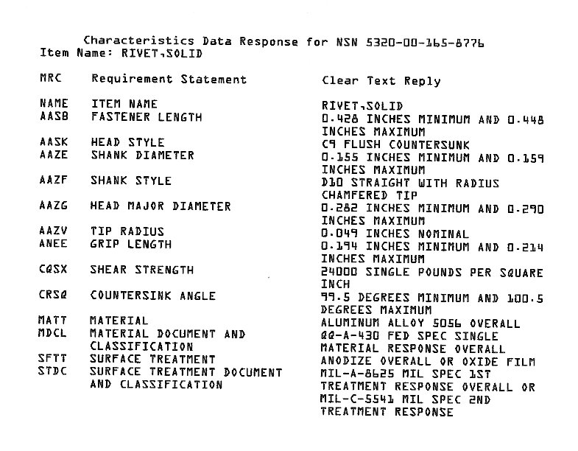
Of interest to us are the following tolerances:

A. Fastener Length: .022”
B. Shank Diameter: .004”
C. Head Major Diameter: .008”
D. Grip Length: .020”
E. Countersink Angle: 99.5 Degrees Minimum & 100.5 Degrees Maximum

ASSUMPTIONS: We’re assuming that the thickness of the same parts on both wings is the same. We’re also assuming that the builder is using the same stainless steel dimple dies and that the pilots for those dimple dies are #40 and #30 respectively.

THE WORK: When a rivet is set, the material first flows to fill the hole and then the shop head (bucktail) is formed. Given all these tolerances, what then is under the builder’s control?

What is under the builder’s control is to final size the hole as precisely as possible and to correctly prepare it for the dimpling/riveting process. Several things can affect this:

A builder is either going to drill a prepunched hole to final size or they are going to ream the hole to final size. Both operations are going to be done with hand tools. Therefore, the likelihood of drilling or reaming a hole exactly perpendicular to the work surface is minimal. However, a drill bit is designed to cut through solids. The first thing it wants to do is grab and twist as it finds material to cut. In our scenario, at best the builder would be using the outer .002 of each end of the drill bit to final size the hole. A reamer is designed to final size existing holes and is the proper tool to use. A reamer is also held to much tighter tolerances than a drill bit.

If a hole is not deburred there is a chance that the parts will not fit flush against each other. A portion of the rivet will flow to fill that tiny gap and it can later become a “working” rivet. If a builder deburrs a hole too much it leaves knife-edges on both sides of the material. With the quality of current kits a builder should ensure they are “deburring” as opposed to “removing material”.

If a hole is not final sized to the diameter of the pilot on the dimple dies, the pilot is then forced to expand the material to size. This can cause microscopic cracking in the material.

If working in close tolerance or blind areas, a builder can use drill bushings of various types to ensure that the hole is drilled perpendicular to the work pieces.

SUMMARY:

One of the most attractive features about building your own aircraft is that you can build it “your” way, but we’ve never met a builder yet who didn’t want to do it to the best of their ability. However, there are a great many things a builder does not have control over, but may or may not understand. In looking at all the possible combinations of tolerances above, each meeting “the specifications”, one begins to understand this. Having factual knowledge of a process can only enable a builder to make better-informed decisions regarding their work.

The MilSpec tolerances for preparing a hole and installing solid rivets can be found on at least two(2) builder’s web sites:

Gil Alexander
http://www.flash.net/~gila/

Dan Checkoway
http://www.rvproject.com/

It’s very revealing just how much latitude a builder has.

Blue Skies!

